

|  |  |  |
| --- | --- | --- |
| Document name | Architecture Document  Novartis_iPortal | System Recruitment Specification |
| Version no. | 0.5 | 1.2 |
| Release date | 25-Dec-13 | 1st Oct ‘09 |
| Document ID | iPortal/AD |  |
| Classification | Confidential |  |

This document of Cybage Software Pvt. Ltd. is for restricted circulation. No part of this publication may be reproduced, stored in a retrieval system or transmitted in any form or by any means – recording, photocopying, electronic and mechanical, without prior written permission of Cybage Software Pvt. Ltd.

|  |
| --- |
| Architecture Document (AD) |

**Document History**

| Ver. No | Release Date | Created By / Modified By and Date | Reviewed By and Date | Approved By and Date | Remarks and Changes Made |
| --- | --- | --- | --- | --- | --- |
| 0.1 | 27-Nov-13 | Trupti Jangam / 27-Nov-13 |  |  | First draft |
| 0.2 | 04-Dec-13 | Trupti Jangam / 04-Dec-13 |  |  | Second draft |
| 0.3 | 11-Dec-13 | Trupti Jangam / 11-Dec-13 |  |  | Third draft |
| 0.4 | 18-Dec-13 | Trupti Jangam / 18-Dec-13 |  |  | Fourth draft |
| 0.5 | 25-Dec-13 | Trupti Jangam / 25-Dec-13 |  |  | Fifth draft |

**Distribution List**

| Sr. No. | Name | Role | Organization Name |
| --- | --- | --- | --- |
|  | Abhijay Datta | Associate Director | Novartis |
|  | Eric Chiu | Solution Architect | Novartis |
|  | Wilson Furtado | Delivery Manager | Cybage |
|  | Ashish Rathi | Project Manager | Cybage |

Table of Contents

1. Introduction 4

1.1 Purpose of the Document 4

1.2 Objective of Architecture Document 4

1.3 Scope of Architecture Document 4

1.4 Acronyms and Definitions 4

1.5 References 5

2. Architecture Goals and Constraints 5

3. Physical Architecture 5

3.1 Physical Architecture 5

3.1.1 Software Requirements 5

3.1.2 Network Requirements 6

4. Logical Architecture 6

4.1 System Overview 6

4.2 Logical Sub-system 9

4.2.1 Activation & Login 9

4.2.2 Document Management 13

4.2.3 SafetyNotification Management 27

4.2.4 Adaptive Monitoring Management 38

4.3 Deployment and Build Script 58

4.4 Project Directory Structure 58

5. Process View 59

6. Architectural Strategies 59

6.1 Tools/RoR Frameworks Used 59

6.2 Technoloy Stack & Third Party Gems 62

6.3 Session Handling 70

6.4 Exception Handling 71

6.4 Logging and Auditing 71

6.4 Security Strategies 71

7. Appendix 73

# Introduction

This document will be used for depicting all the Architectural designs of **iPortal** project developed for client **Novartis**.

## Purpose of the Document

The purpose of this document is to

* Identify various components/objects in the sub-system to granular level
* Identify core modules/sub-systems of the system and sub-system boundary.
* Design detailed class diagram, sequence diagram, activity diagram, and so on.
* Identify database design (physical, logical, and more).
* Identify data structures and algorithm.
* Identify various R&D issues.
* Identify the technology stack required to deploy the application, and document the build/package/deployment process

## Objective of Architecture Document

The objectives of this AD are

* To capture and convey all the important architectural decisions taken.
* To identify and understand workflows involved
* To identify possible effects on the system in case of any further enhancements

## Scope of Architecture Document

The scope of AD is

* Account activation & Login
* Document Management
* Safety Notification Management
* Adaptive Monitoring Management
* Admin Dashboard Management

## Acronyms and Definitions

This sub-section includes the definitions of all acronyms required to interpret the AD properly.

| Sr. No. | Acronyms | Definitions |
| --- | --- | --- |
|  | Imp | Investigational Medicinal Product |
|  | CPO | Country Pharmaceutical Organization |
|  | SN/Sn | Safety Notification |
|  | Sn_version | Safety Notification Version |
|  | Sn_type | Safety Notification Type |
|  | Sn_country_ack | Safety Notification Acknowledgement |
|  | Sn_site_ack | Safety Notification Site Acknowledgement |
|  | Sn_study_country_ack | Safety Notification Study Country Acknowledgement |
|  | Ccra | Central CRA |
|  | Fm | Field Monitor |

## References

This sub-section provides a complete list of all documents referenced elsewhere in the AD with the details of the sources from which the references can be obtained.

# Architecture Goals and Constraints

* Authentication should be done with Devise

# Physical Architecture

## Physical Architecture

<Physical architecture diagram to be added>

### Software Requirements

**Production**

Web server – Linux, Ruby on rails, All necessary Gems

Database server – PostreSql

**Test / Development**

Web server – Linux, Ruby on rails, All necessary Gems

Database server – PostgreSql

### Network Requirements

* Internet connection

# Logical Architecture

## System Overview

This section will contain overall system overview diagram and description for the pattern followed by the system.

### System Overview Diagram



### Pattern Used - MVC

Model View Controller or MVC as it is popularly called, is a software design pattern for developing web applications. Following diagram describes MVC pattern in **Ruby on Rails** application.

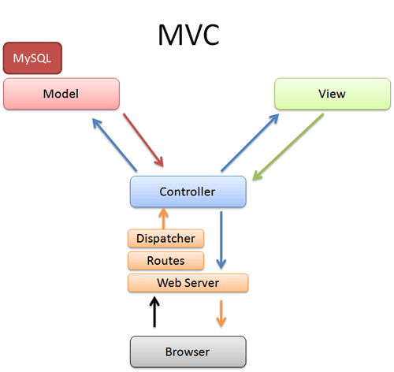

### Model (ActiveRecord )

Maintains the relationship between Object and Database and handles validation, association, transactions, and more.

This subsystem is implemented in ActiveRecord library which provides an interface and binding between the tables in a relational database and the Ruby program code that manipulates database records. Ruby method names are automatically generated from the field names of database tables, and so on. ActiveRecord is a GEM and it is located under rvm dependencies. Whenever rails is installed, ActiveRecord gets automatically installed as its runtime dependency.

### View ( ActionView )

A presentation of data in a particular format is triggered by a controller's decision to present the data. They are script based templating systems like JSP, ASP, PHP and very easy to integrate with AJAX technology.

This subsystem is implemented in ActionView library which is an Embedded Ruby (ERb) based system for defining presentation templates for data presentation. Every Web connection to a Rails application results in the displaying of a view. ActionView is a GEM and it is located under rvm dependencies. It is a component of ActionPack GEM. Whenever rails is installed, ActionPack gets automatically installed as its runtime dependency.

### Controller ( ActionController )

The facility within the application directs traffic, on the one hand querying the models for specific data, and on the other hand organizing that data (searching, sorting, and messaging it) into a form that fits the needs of a given view.

This subsystem is implemented in ActionController which is a data broker sitting between ActiveRecord (the database interface) and ActionView (the presentation engine).

ActionController is a GEM and it is located under rvm dependencies. It is a component of ActionPack GEM. Whenever rails is installed, ActionPack gets automatically installed as its runtime dependency.

When user requests the url, controller parses the request, route and dispatch it to the appropriate method with the help of dispatcher, asks for model data and gives that data to view component. Controller also manages sessions, caching of data, view helpers.

*Directory Representation for Rails MVC Framework:*

Assuming a standard, default installation over Linux, ActiveRecord, ActionView and ActionController libraries/gems can be find like this:

$> cd /usr/local/lib/ruby/gems/1.9/gems

$> ls

Many sub-directories including following will be seen:

* actionpack-x.y.z
* activerecord-x.y.z
* rails-x.y.z

activerecord-x.y.z is the actual ActiveRecord library.

While ActionView and ActionController can be find under actionpack-x.y.z library.

## Logical Sub-system

A Logical System may have one or more sub-systems associated with it. Following section will list all the identified subsystem and describe each individual subsystem.

### Account Activation & Login

This section describes the functionality and responsibilities of the system identified.

#### Purpose

Account activation and Login is part of an application. In Account Activation, when user is account is created with iPortal, user will receive email with activation link. Following the link will activate the user account.

Once the account is successfully activated, user can login into the system with his credentials.

#### Logical Architecture Diagram

#### Object Model and Interface

Class Diagrams - <Yet to fill>

Flow Diagrams :

Account Activation Flow Diagram



Login Flow Diagram



Sequence Diagrams

Sequence Diagrams for Account Activation

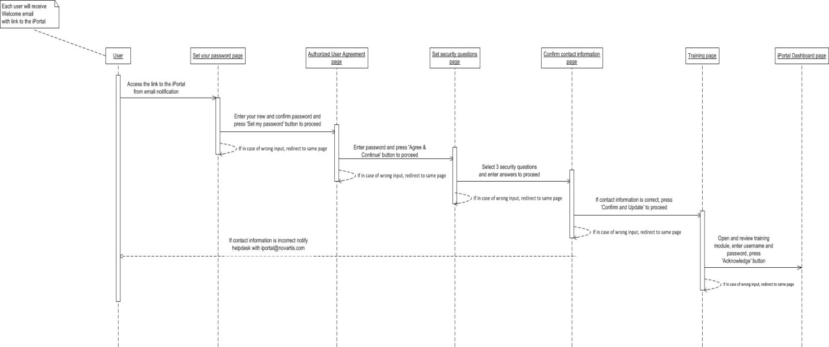

Component Description for Account Activation

<Not fill yet>

Sequence Diagram for Login

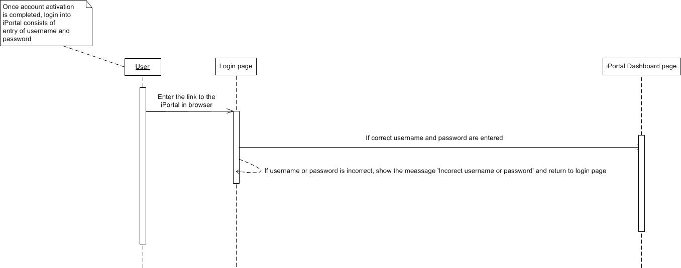

Component Description for Login

Please refer following document for more description about classes, methods and models involved in Login.



#### Service APIs

No service is used in account activation or login.

#### Database and Data Requirements

<Yet to fill>

#### Project Structure

Refer project structure from 4.4 section

#### Deployment/Setup Requirement

Refer deployment and setup script from section 4.3 Deployment and Build script

#### Test Guidelines

Cucumber framework is used to test the components.

#### Assumptions

Only those users whose accounts are created with the iPortal system will get account activation emails.

Only those users whose accounts are activated, can be able to login into the application.

Validation is present for authenticated users.

#### Dependencies on other Subsystem

All other sub-systems depend on account activation and login.

No user is allowed to login into the system before account activation.

No user is allowed to access the system before login.

#### Component Matrix

The below section describes the matrix of dependencies for the various components\classes identified for this sub-system.

<Yet to fill>

### Document Management

This section describes the functionality and responsibilities of the system identified.

#### Purpose

Document management system is responsible for uploading documents into the iPortal system.

Documents can be created with specific type of access. Documents can also be downloaded.

#### Logical Architecture Diagram

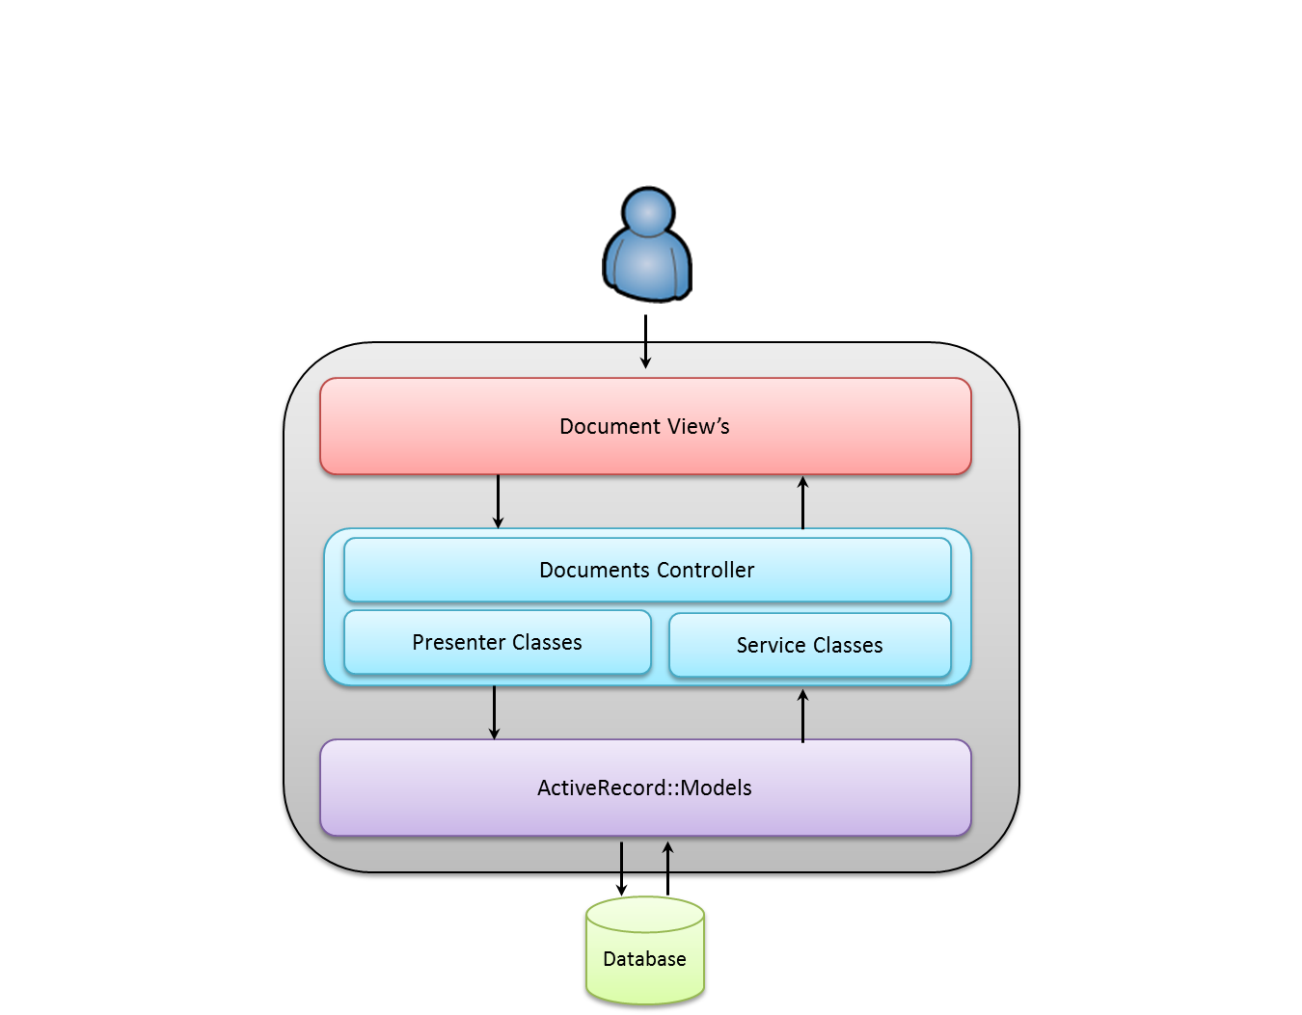

#### Object Model and Interface

Class diagrams:



*Document Class Description*

For Document class description refer below document.



Flow Diagram:



Sequence Diagrams:

For All Users



Sequence table

|  |  |
| --- | --- |
| Sequence No. | Action |
| 1 | From iPortal Dashboard, select ‘Document’ tab |
| 2 | From Document Home Page press ‘Upload New Document’ button |
| 3.1 | Select type of access for this document as ‘All iPortal Users’ and press ‘Select Files’ to proceed |
| 3.2 | If pop-up is cancelled, return to previous page |
| 3.3 | If in case of wrong input  return to same page |
| 4.1 | Select files to upload and press ‘Confirm’ to proceed |
| 4.2 | Press ‘Document Access’ button to return to previous Document Access page |
| 4.3 | If pop-up is cancelled, return to Document Home Page |
| 4.4 | If in case of wrong input or cancel document or change file name or add comment  return to same page |
| 5.1 | Press ‘Upload Documents’ button to upload documents and redirect to Document Home Page |
| 5.2 | Press ‘Select Files’ button to return to previous Select Files page |
| 5.3 | If pop-up is cancelled, return to Document Home Page |

For Study



Sequence table

|  |  |
| --- | --- |
| Sequence No. | Action |
| 1 | From iPortal Dashboard, select ‘Document’ tab |
| 2 | From Document Home Page press ‘Upload New Document’ button |
| 3.1 | Select type of access for this document as ‘By Study’, select Study from the dropdown list and press ‘Select Files’ to proceed |
| 3.2 | If pop-up is cancelled, return to previous page |
| 3.3 | If in case of wrong input  return to same page |
| 4.1 | Select files to upload and press ‘Confirm’ to proceed |
| 4.2 | Press ‘Document Access’ button to return to previous Document Access page |
| 4.3 | If pop-up is cancelled, return to Document Home Page |
| 4.4 | If in case of wrong input or cancel document or change file name or add comment  return to same page |
| 5.1 | Press ‘Upload Documents’ button to upload documents and redirect to Document Home Page |
| 5.2 | Press ‘Select Files’ button to return to previous Select Files page |
| 5.3 | If pop-up is cancelled, return to Document Home Page |

For Imp



Sequence table

|  |  |
| --- | --- |
| Sequence No. | Action |
| 1 | From iPortal Dashboard, select ‘Document’ tab |
| 2 | From Document Home Page press ‘Upload New Document’ button |
| 3.1 | Select type of access for this document as ‘By Imp’, select Imp from the dropdown list and press ‘Select Files’ to proceed |
| 3.2 | If pop-up is cancelled, return to previous page |
| 3.3 | If in case of wrong input  return to same page |
| 4.1 | Select files to upload and press ‘Confirm’ to proceed |
| 4.2 | Press ‘Document Access’ button to return to previous Document Access page |
| 4.3 | If pop-up is cancelled, return to Document Home Page |
| 4.4 | If in case of wrong input or cancel document or change file name or add comment  return to same page |
| 5.1 | Press ‘Upload Documents’ button to upload documents and redirect to Document Home Page |
| 5.2 | Press ‘Select Files’ button to return to previous Select Files page |
| 5.3 | If pop-up is cancelled, return to Document Home Page |

For Study Country



Sequence table

|  |  |
| --- | --- |
| Sequence No. | Action |
| 1 | From iPortal Dashboard, select ‘Document’ tab |
| 2 | From Document Home Page press ‘Upload New Document’ button |
| 3.1 | Select type of access for this document as ‘By Study Country’, select Study and Study Country from the dropdown list and press ‘Select Files’ to proceed |
| 3.2 | If pop-up is cancelled, return to previous page |
| 3.3 | If in case of wrong input  return to same page |
| 4.1 | Select files to upload and press ‘Confirm’ to proceed |
| 4.2 | Press ‘Document Access’ button to return to previous Document Access page |
| 4.3 | If pop-up is cancelled, return to Document Home Page |
| 4.4 | If in case of wrong input or cancel document or change file name or add comment  return to same page |
| 5.1 | Press ‘Upload Documents’ button to upload documents and redirect to Document Home Page |
| 5.2 | Press ‘Select Files’ button to return to previous Select Files page |
| 5.3 | If pop-up is cancelled, return to Document Home Page |

For Site



Sequence table

|  |  |
| --- | --- |
| Sequence No. | Action |
| 1 | From iPortal Dashboard, select ‘Document’ tab |
| 2 | From Document Home Page press ‘Upload New Document’ button |
| 3.1 | Select type of access for this document as ‘By Site’, select Study and Site from the dropdown list and press ‘Select Files’ to proceed |
| 3.2 | If pop-up is cancelled, return to previous page |
| 3.3 | If in case of wrong input  return to same page |
| 4.1 | Select files to upload and press ‘Confirm’ to proceed |
| 4.2 | Press ‘Document Access’ button to return to previous Document Access page |
| 4.3 | If pop-up is cancelled, return to Document Home Page |
| 4.4 | If in case of wrong input or cancel document or change file name or add comment  return to same page |
| 5.1 | Press ‘Upload Documents’ button to upload documents and redirect to Document Home Page |
| 5.2 | Press ‘Select Files’ button to return to previous Select Files page |
| 5.3 | If pop-up is cancelled, return to Document Home Page |

For Role



Sequence table

|  |  |
| --- | --- |
| Sequence No. | Action |
| 1 | From iPortal Dashboard, select ‘Document’ tab |
| 2 | From Document Home Page press ‘Upload New Document’ button |
| 3.1 | Select type of access for this document as ‘By Role’, select Role and Study from the dropdown list and press ‘Select Files’ to proceed |
| 3.2 | If pop-up is cancelled, return to previous page |
| 3.3 | If in case of wrong input  return to same page |
| 4.1 | Select files to upload and press ‘Confirm’ to proceed |
| 4.2 | Press ‘Document Access’ button to return to previous Document Access page |
| 4.3 | If pop-up is cancelled, return to Document Home Page |
| 4.4 | If in case of wrong input or cancel document or change file name or add comment  return to same page |
| 5.1 | Press ‘Upload Documents’ button to upload documents and redirect to Document Home Page |
| 5.2 | Press ‘Select Files’ button to return to previous Select Files page |
| 5.3 | If pop-up is cancelled, return to Document Home Page |

#### Component Description

Please refer following document for more description about classes, methods and models involved in Document Upload.



#### Service APIs

No service is used in this system.

#### Database and Data Requirements

##### Database ER Diagram



Database Tables Description

For table description refer Appendix1.

#### Project Structure

For project structure refer section 4.4

#### Deployment/Setup Requirement

For deployment and setup requirement refer document from the section 4.3

#### Test Guidelines

Cucumber framework will be used to test the components.

#### Assumptions

Only those users having document upload permissions are expected to upload documents.

#### Constraints

Only those roles given the “Documents -> Create” permissions will have the ability to post documents. Some of the roles that will be given these rights may contain:

* Super Admin
* GTL
* Clinical Trial Team  
  Field Monitor

#### Dependencies on other Subsystem

Document upload is not dependent on any other system but documents uploaded can be accessible to users on Dashboard tab.

#### Component Matrix

<Yet to fill>

### SafetyNotification Management

This section describes the functionality and responsibilities of the system identified.

#### Purpose

Safety Notification system is responsible for local/global safety notification upload. Also responsible for distribution of safety notification to different users from different countries, sites.

#### Logical Architecture Diagram



#### Object Model and Interface

Class Diagrams

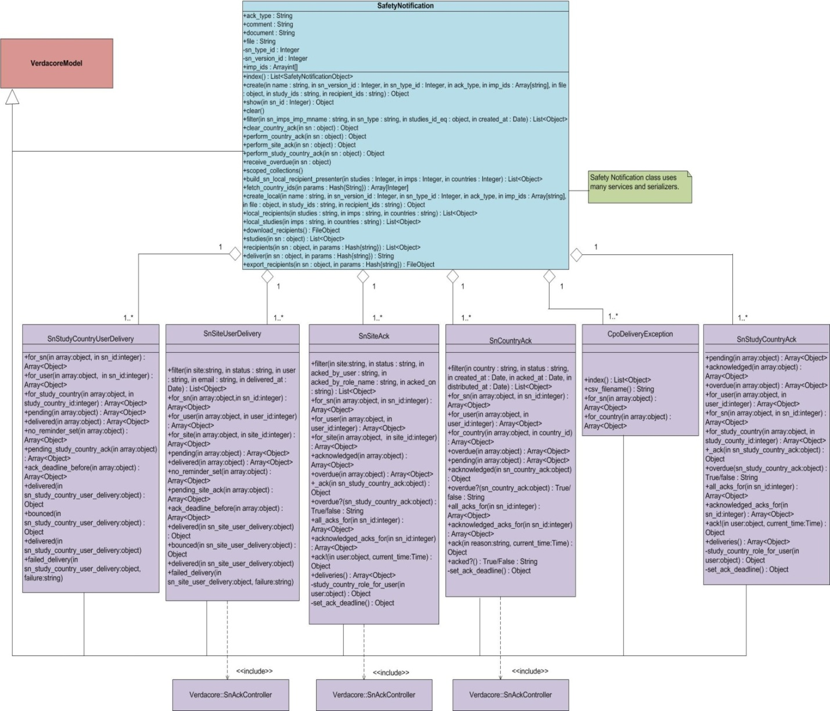

*Class Description*

**

Flow Diagrams

<Yet to fill>

Sequence Diagrams

Global Safety Notification Upload Sequence Diagram :



Sequence table

|  |  |
| --- | --- |
| Sequence No. | Action |
| 1 | From iPortal Dashboard, select ‘Safety Notification’ tab |
| 2 | Select ‘Upload Global Safety Notification’ |
| 3.1 | Enter all the details for Safety Notification and press ‘Confirm Delivery’ to proceed |
| 3.2 | If pop-up is cancelled, return to previous page |
| 3.3 | In case of wrong input, redirect to same pop-up |
| 4.1 | Click ‘Upload’ to upload Safety Notification |
| 4.2 | Click ‘Safety Notification Details’ to return to previous page |
| 4.3 | If pop-up is cancelled, return to previous page |
| 4.4 | In case of wrong input, redirect to same pop-up |

Local Safety Notification Upload Sequence Diagram :



Sequence table

|  |  |
| --- | --- |
| Sequence No. | Action |
| 1 | From iPortal Dashboard, select ‘Safety Notification’ tab |
| 2 | Select ‘Upload Safety Notification’ |
| 3.1 | Enter all the details for Safety Notification and press ‘Select Studies’ to proceed |
| 3.2 | Close pop-up to return to previous page |
| 3.3 | In case of wrong Input, return to Same page |
| 4.1 | Select studies from the list of studies displayed and press ‘Select Recipients’ button to proceed |
| 4.2 | Press ‘Safety Notification Details’ button to return to previous page |
| 4.3 | Close pop-up to return to Safety Notification tab |
| 4.4 | In case of wrong Input, return to Same page |
| 5.1 | Select recipients by Roles or by Individuals and press ‘Confirm Delivery’ button to proceed |
| 5.2 | Press ‘Select Studies’ to return to the previous page |
| 5.3 | Close pop-up to return to Safety Notification tab |
| 5.4 | In case of wrong Input, return to Same page |
| 6.1 | Press ‘Upload and Deliver Notifications’ button to uplaod notifications |
| 6.2 | Press ‘Select Recipients’ to return to previous page |
| 6.3 | Close pop-up to return to Safety Notification tab |
| 6.4 | In case of wrong Input, return to Same page |

CPO Acknowledgement for No Distribution Sequence Diagram :



Sequence table for CPO Acknowledgement for No Distribution

|  |  |
| --- | --- |
| Sequence No. | Action |
| 1 | From iPortal Dashboard, select ‘Safety Notification’ tab |
| 2 | Select Safety Notification which is to be distributed |
| 3 | If ‘Acknowledge (No Distribution)’ is selected for a particular country |
| 4.1 | Enter reason for no distribution and press ‘Acknowledgement (No Distribution Necessary)’ to proceed |
| 4.2 | Click ‘Cancel’ to return to previous page |
| 4.3 | In case of wrong  Input, return to  Same page |

CPO Acknowledgement for Select & Distribute Sequence Diagram :



Sequence table

|  |  |
| --- | --- |
| Sequence No. | Action |
| 1 | From iPortal Dashboard, select ‘Safety Notification’ tab |
| 2 | Select Safety Notification which is to be distributed |
| 3 | If ‘Select & Deliver Now’ is selected for a particular country |
| 4.1 | Select studies from the list of studies displayed and press ‘Select Recipients’ button to proceed |
| 4.2 | Press ‘Cancel’ to return to previous page |
| 4.3 | In case of wrong  Input, return to  Same page |
| 5.1 | Select recipients by Roles or by Individuals and press ‘Confirm Delivery’ button to proceed |
| 5.2 | Press ‘Select Studies’ to return to previous page |
| 5.3 | Close the pop-up to return to Safety Notification show page |
| 5.4 | In case of wrong Input return to same page |
| 6.1 | Press ‘Deliver Notifications’ button to deliver the notifications and proceed |
| 6.2 | Press ‘Select Recipients’ to return to previous page |
| 6.3 | Close the pop-up to return to Safety Notification show page |
| 6.4 | In case of wrong Input return to same page |
| 7 | After acknowledging/ delivering to the sites, “Country Acknowledgements” tab provides status |

#### Component Description

Please refer following document for more description about classes, methods and models involved in Safety Notification.



#### Service APIs

No service is used in the system.

#### Database and Data Requirements

##### Database ER Diagram



Database table description

For table description refer Appendix2.

#### Project Structure

For project structure refer section 4.4

#### Deployment/Setup Requirement

For deployment and setup refer document from section 4.3

#### Test Guidelines

Cucumber framework is used to test the componenets.

#### Assumptions

Each trial will have certain safety precautions and results. All these should be uploaded under safty notification section so that other users which are working on the same trial should be notified.

#### Constraints

Global safety notification upload is done by users from Novartis head Quarter.

CPO for each country is responsible for Local safety notifications for that country.

#### Dependencies on other Subsystem

Safety Notification has Country, Site and Study level dependency.

Admin creates Safety Notification versions and types so this system has dependency on Admin Dashboard system.

#### Component Matrix

<Yet to fill>

### Adaptive Monitoring Management

This section describes the functionality and responsibilities of the system identified.

#### Purpose

Adaptive Monitoring system is responsible for uploading CAF reports and managing site observations, site decisions by CCRA and FM.

#### Logical Architecture Diagram



#### Object Model and Interface

Class Diagram



Class Description

<Yet to fill>

Flow Diagram

<Yet to fill>

Sequence Diagrams

Seq Diagram for CAF Analyst



Sequence table

|  |  |
| --- | --- |
| Sequence No. | Action |
| 1 | From iPortal Dashboard, select ‘Adaptive Monitoring -> CAF Reports’ tab |
| 2 | To load new CAF Report, press ‘New CAF Report’ button |
| 3.1 | 1.Select the Study from dropdown  2.press Browse and Select file to upload  3.Press ‘Create CAF Report’ button to proceed |
| 3.2 | Press ‘Cancel’ button to return to CAF Report Home Page |
| 4.1 | When report is uploaded successfully |
| 4.2 | select ‘Adaptive Monitoring -> CAF Reports’ tab to return to CAF Report Home Page |
| 5 | If you leave the CAF Report Upload screen or log out of iPortal without selecting Process, Cancel or Disable, the loaded report will be displayed on the AM CAF Report homepage with a status of ‘Validated’ |

Seq Diagram for CAF Report load failue



Sequence table

|  |  |
| --- | --- |
| Sequence No. | Action |
| 1 | From iPortal Dashboard, select ‘Adaptive Monitoring -> CAF Reports’ tab |
| 2 | Click on the report title to open the CAF Report for further processing |
| 3.1 | User press the ‘Process CAF Report’ button, but report has failed to upload |
| 3.2 | select ‘Adaptive Monitoring -> CAF Reports’ tab to return to CAF Report Home Page |
| 4 | select ‘Adaptive Monitoring -> CAF Reports’ tab to return to CAF Report Home Page |

Seq Diagram to Process uploaded CAF Report



Sequence table

|  |  |
| --- | --- |
| Sequence No. | Action |
| 1 | From iPortal Dashboard, select ‘Adaptive Monitoring -> CAF Reports’ tab |
| 2 | Click on the report title to open the CAF Report for further processing |
| 3.1 | To process the uploaded CAF Report, press the ‘Process CAF Report’ button |
| 3.1 | select ‘Adaptive Monitoring -> CAF Reports’ tab to return to CAF Report Home Page |

Seq Diagram to Cancel uploaded CAF Report



Sequence table

|  |  |
| --- | --- |
| Sequence No. | Action |
| 1 | From iPortal Dashboard, select ‘Adaptive Monitoring -> CAF Reports’ tab |
| 2 | Click on the report title to open the CAF Report for further processing |
| 3.1 | If the report has been loaded in error press the ‘Cancel CAF Report’ button to cancel the report. |
| 3.2 | select ‘Adaptive Monitoring -> CAF Reports’ tab to return to CAF Report Home Page |

Seq Diagram to Disable a porcessed CAF Report



Sequence table

|  |  |
| --- | --- |
| Sequence No. | Action |
| 1 | From iPortal Dashboard, select ‘Adaptive Monitoring -> CAF Reports’ tab |
| 2 | Click on the report title to open the CAF Report for further processing |
| 3.1 | Press the ‘Disable’ button, to disable the report |
| 3.1 | select ‘Adaptive Monitoring -> CAF Reports’ tab to return to CAF Report Home Page |
| 4.1 | Press ‘Ok’ to disable the report and proceed |
| 4.2 | Press ‘Cancel’ to close the pop-up |

Seq Diagram for CCRA to View Site and Enter Site Observation



Sequence table

|  |  |
| --- | --- |
| Sequence No. | Action |
| 1 | From iPortal Dashboard, select ‘Adaptive Monitoring -> Sites’ tab |
| 2 | Press ‘View’ to See detailed site information & Enter an observation |
| 3 | Press ‘Create New Observation’ to enter a site level observation |
| 4.1 | 1.Enter Observation Text  2.Select if Actionable to FM or Not (Yes / No)  3.Press ‘Create Site Observation’ to create new Site Observation |
| 4.2 | Press ‘Cancel’ to return to previous page |

Seq Diagram for CCRA to Edit Site Observation



Sequence table for

|  |  |
| --- | --- |
| Sequence No. | Action |
| 1 | From iPortal Dashboard, select ‘Adaptive Monitoring -> Sites’ tab |
| 2 | Press ‘View’ to See detailed site information & Enter an observation |
| 3 | Press ‘Edit’ to edit the site level observation |
| 4.1 | Press ‘Update Site Observation’ to update the Site Observation |
| 4.2 | Press ‘Cancel’ to return to previous page |

Seq Diagram for CCRA to Delete Site Observation



Sequence table

|  |  |
| --- | --- |
| Sequence No. | Action |
| 1 | From iPortal Dashboard, select ‘Adaptive Monitoring -> Sites’ tab |
| 2 | Press ‘View’ to See detailed site information |
| 3 | Press ‘Delete’ to delete the site level observation |

Seq Diagram for CCRA to Review and Accept FM Observation Response



Sequence table

|  |  |
| --- | --- |
| Sequence No. | Action |
| 1 | From iPortal Dashboard, select ‘Adaptive Monitoring -> Sites’ tab |
| 2 | Press ‘View’ to See detailed site information |
| 3 | When CCRA press ‘Accept Response’ Button  For any of the FM response then the status for that response is changed to close |

Seq Diagram for CCRA to Review and Reject FM Observation Response



Sequence table

|  |  |
| --- | --- |
| Sequence No. | Action |
| 1 | From iPortal Dashboard, select ‘Adaptive Monitoring -> Sites’ tab |
| 2 | Press ‘View’ to See detailed site information |
| 3 | Press ‘Reject Response’ button  for any of the FM observation response to reject the response |
| 4.1 | Enter Reason for Rejection which is mandatory and Press ‘Save as Draft’ to save |
| 4.2 | Press ‘Cancel’ to return to previous page |

Seq Diagram for Entering Central Recommendation for Recommended_No



Sequence table

|  |  |
| --- | --- |
| Sequence No. | Action |
| 1 | From iPortal Dashboard, select ‘Adaptive Monitoring -> Sites’ tab |
| 2 | Press ‘View’ to See detailed site information |
| 3 | Press ‘Enter Central Recommendation’ to provide the consolidated CAF / Central Monitor that will be seen and acted upon by the FM |
| 4 | If CCRA selects Recommended equal to ‘No’ then he may enter a **NON-MANDATORY** comment if desired but he must select reason from dropdown list and Press ‘Create Central Recommendation’ |
| 5 | Press the ‘Submit AM Report’ to submit the AM package to the FM |

Seq Diagram for Entering Central Recommendation for Recommended_Yes



Sequence table

|  |  |
| --- | --- |
| Sequence No. | Action |
| 1 | From iPortal Dashboard, select ‘Adaptive Monitoring -> Sites’ tab |
| 2 | Press ‘View’ to See detailed site information |
| 3 | Press ‘Enter Central Recommendation’ to provide the consolidated CAF / Central Monitor that will be seen and acted upon by the FM |
| 4 | If CCRA selects Recommended equal to ‘Yes’ then he may enter a **NON-MANDATORY** comment if desired and Press ‘Create Central Recommendation’ |
| 5 | Press the ‘Submit AM Report’ to submit the AM package to the FM |

Seq Diagram for FM to respond to CCRA Queries



Sequence table

|  |  |
| --- | --- |
| Sequence No. | Action |
| 1 | From iPortal Dashboard, select ‘Adaptive Monitoring -> Sites’ tab |
| 2 | Press ‘View’ to See detailed site information |
| 3 | Press ‘Respond’ button to respond to the CCRA observations |
| 4.1 | Enter observation response and press ‘Save as Draft’ to save the response |
| 4.2 | Press ‘Cancel’ to return to previous page |
| 5 | Press ‘Submit’ to route the response back to the CCRA  Once Submitted the Status is Changed from ‘Open’ to ‘In Review CCRA’ and no further actions on that observation are available |

Seq Diagram for FM to respond to Rejected CCRA Queries



Sequence table

|  |  |
| --- | --- |
| Sequence No. | Action |
| 1 | From iPortal Dashboard, select ‘Adaptive Monitoring -> Sites’ tab |
| 2 | Press ‘View’ to See detailed site information |
| 3 | Press ‘Respond’ button to respond to the CCRA rejected observation response |
| 4.1 | Enter observation response and press ‘Save as Draft’ to save the response |
| 4.2 | Press ‘Cancel’ to return to previous page |
| 5 | Press ‘Submit’ to route the response back to the CCRA  Once Submitted the Status is Changed from ‘In Review FM’ to ‘In Review CCRA’ and no further actions on that observation are available |

Seq Diagram for FM to Enter Site Decision No



Sequence table

|  |  |
| --- | --- |
| Sequence No. | Action |
| 1 | From iPortal Dashboard, select ‘Adaptive Monitoring -> Sites’ tab |
| 2 | Press ‘View’ to See detailed site information |
| 3 | Press ‘Create Site Decision’ to enter Yes or No |
| 4.1 | 1. Select Approved = No  2) Enter Reason from Drop Down list (Multiple reasons can be selected)  3) Enter MANDATORY comment  4) Enter MANDATORY Action Plan (My VR # and expected completion date). If there are multiple MyVR #s click on the Enter Action Plan button for each MyVR # that needs to be entered  5) Press Submit |
| 4.2 | Press ‘Cancel’ to return to previous page |
| 5 | Press Site Decision ‘Details’ button to view Site Decision Details page |
| 6 | Press ‘Cancel’ to return to previous page |

Seq Diagram for FM to Enter Site Decision Yes



Sequence table for Seq Diagram for FM to Enter Site Decision Yes

|  |  |
| --- | --- |
| Sequence No. | Action |
| 1 | From iPortal Dashboard, select ‘Adaptive Monitoring -> Sites’ tab |
| 2 | Press ‘View’ to See detailed site information |
| 3 | Press ‘Create Site Decision’ to enter Yes or No |
| 4.1 | Select Approved = Yes and Enter Comments.  Press ‘Submit’ to submit the decision or press ‘Save as Draft’ to save the decision for further editing |
| 4.2 | Press ‘Cancel’ to return to previous page |
| 5 | Press Site Decision ‘Details’ button to view Site Decision Details page |
| 6 | Press ‘Cancel’ to return to previous page |

Component Description



#### Service APIs

This system uses no external service.

#### Database and Data Requirements



Database Description

For database description refer Appendix3

#### Project Structure

For project structure refer section 4.4

#### Deployment/Setup Requirement

For deployment and setup refer section 4.3

#### Test Guidelines

Cucumber framework is used to test the components.

#### Assumptions

No specific assumptions.

#### Constraints

Users involved in this system can have one of the following role.

* CAF Analyst
* CCRA
* FM

#### Dependencies on other Subsystem

This system has dependency on Admin Dashboard system.

#### Component Matrix

<Yet to fill>

## Deployment and Build Script

For Deployment script refer Deployment Script document.

For Environment setup & Build script refer Environment & Build Script document.



## Project Directory Structure

Console View

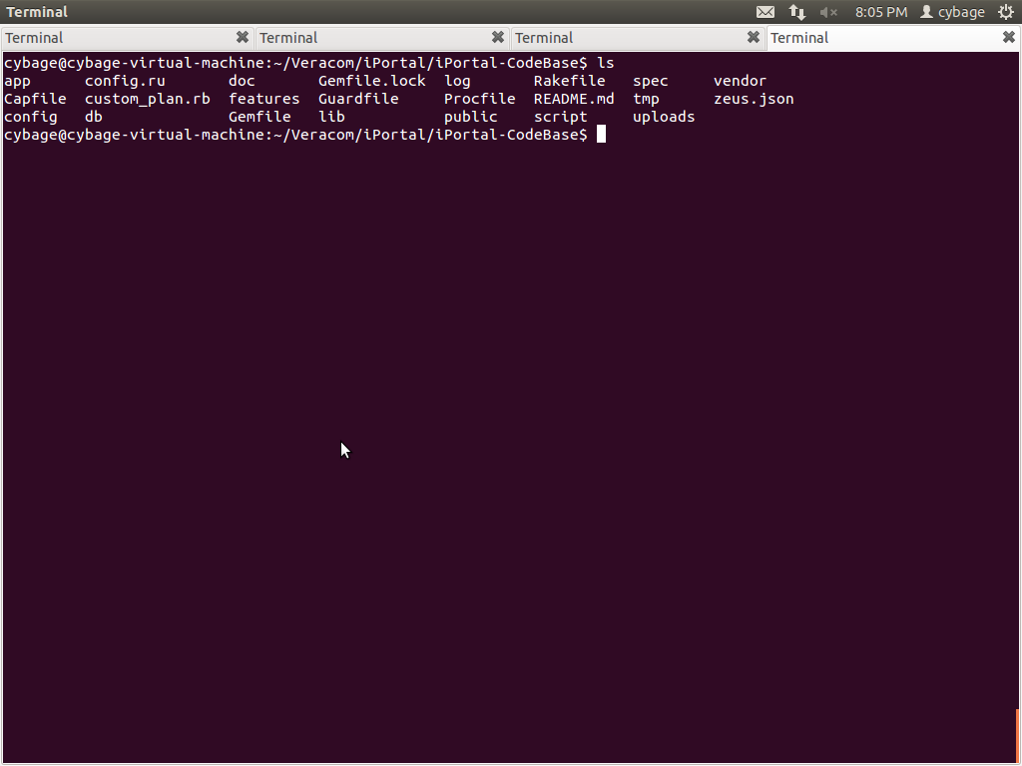

Folder View

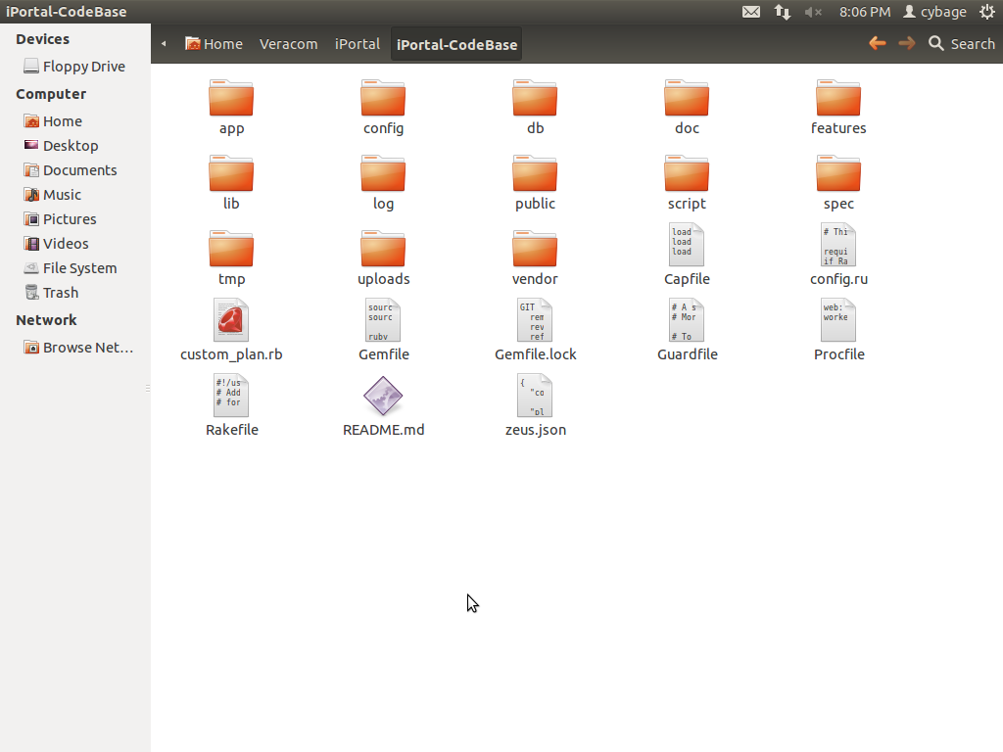

# Process View

<Yet to fill>

# Architectural Strategies

This section describes features or strategies used in designing the architecture of the application. These strategies also provide insight into the key abstractions and mechanisms used in the system architecture. Following are few strategies which can be mentioned in this section:

## Tools/RoR Frameworks Used

This section will describe any tools/RoR frameworks to be used in the application.

| Framework | Environment ( Runtime/Testing) | Description |
| --- | --- | --- |
| ActiveAdmin | Runtime | ActiveAdmin is the administration framework for business critical Ruby on Rails applications. It is used for generating administration style interfaces. It abstracts common business application patterns to make it simple for developers implement beautiful and elegant interfaces with very little effort. Allow developers to customize every nook and cranny of the interface easily. |
| Jquery | Runtime | jQuery is a fast, small, and feature-rich JavaScript framework. It makes things like HTML document traversal and manipulation, event handling, animation, and Ajax much simpler with an easy-to-use API that works across a multitude of browsers. With a combination of versatility and extensibility, jQuery has changed the way that millions of people write JavaScript. |
| Capistrano | Runtime | Capistrano is a remote server automation tool. It supports the scripting and execution of arbitrary tasks, and includes a set of sane-default deployment workflows. It reliably deploy web application to any number of machines simultaneously, in sequence or as a rolling set. |
| Capybara | Testing | Capybara is acceptance test framework for rack based web applications. Capybara helps you test web applications by simulating how a real user would interact with your app. It is agnostic about the driver running your tests and comes with Rack::Test and Selenium support built in. WebKit is also supported through an external gem. |
| Cucumber | Testing | Cucumber is Behavior Driven Development framework. Cucumber lets software development teams describe how software should behave in plain text. The text is written in a business readable domain specific language and serves as documentation, automated tests and development-id, all rolled into one format. |
| Shulda | Testing | Shulda make tests easy shoulda-context and shulda-matchers. Shoulda's contexts make it easy to write understandable and maintainable tests for Test::Unit. It's fully compatible with your existing tests in Test::Unit, and requires no retooling to use.  shoulda-matchers provides Test::Unit- and RSpec-compatible one-liners that test common Rails functionality. These tests would otherwise be much longer, more complex, and error-prone. |

## Technology Stack Used & Third Party Gems

Technology Stack:

A technology stack comprises the layers of components or services that are used to provide a software solution or application. iPortal application uses following technology stack.

* Language – Ruby
* Web Framework – Rails
* Web Server – Thin, Unicorn
* Relational Database – Postgresql
* Operating System – Linux
* Cloud Pass Solution - EngineYard

Third party Gems

The below section describes third party gems/libraries used in the system.

| Gem Name | Version | Environment (Development, Test, Production) | Description |
| --- | --- | --- | --- |
| rails | 3.2.14 | All | Rails are a web-application framework that includes everything needed to create database-backed web applications according to the Model-View-Controller (MVC) pattern. |
| pg | - | All | Pg is the Ruby interface to the PostgreSQL RDBMS. It works with PostgreSQL 8.4 and later. |
| active_admin | - | All | Active Admin is a Ruby on Rails framework for creating elegant backends for website administration. |
| devise | 2.2.4 | All | Devise is a flexible authentication solution for Rails |
| nokogiri | 1.5.10 | All | Nokogiri is an HTML, XML, SAX and Reader parser. |
| active_model_serializers | 0.8.0 | All | ActiveModel::Serializer implementation and Rails hooks |
| carrierwave | - | All | This gem provides a simple and extremely flexible way to upload files from Ruby applications. It works well with Rack based web applications, such as Ruby on Rails. |
| sendgrid | - | All | SendGrid is an awesome service that helps you send large amounts of email (bells and whistles included) without spending large amounts of money. This gem allows for painless integration between ActionMailer and the SendGrid SMTP API. |
| ffaker | - | All | A library for generating fake data such as names, addresses, and phone numbers |
| chosen-rails | - | All | Integrate Chosen javascript library with Rails asset pipeline. Chosen is a library for making long, unwieldy select boxes more user friendly. |
| select2-rails | 3.4.2 | All | Integrate Select2 javascript library with Rails asset pipeline. Select2 is a jQuery based replacement for select boxes. It supports searching, remote data sets, and infinite scrolling of results. |
| sort_alphbetical | - | All | Ruby: sort UTF8 Strings alphabetical via Enumerable extension |
| cocoon | - | All | Dynamic nested forms using jQuery made easy; works with formtastic, simple_form or default forms |
| delayed_job_active_record | - | All | ActiveRecord backend integration for DelayedJob 3.0+ |
| airbrake | - | All | This is the notifier gem for integrating apps with Airbrake. When an uncaught exception occurs, Airbrake will POST the relevant data to the Airbrake server specified in your environment. |
| whenever | - | All | Whenever is a Ruby gem that provides a clear syntax for writing and deploying cron jobs. |
| naught | - | All | A toolkit for building Null Object classes in Ruby. |
| psych | - | All | Psych is a YAML parser and emitter. Psych leverages [libyaml](http://pyyaml.org/wiki/LibYAML) for its YAML parsing and emitting capabilities. In addition to wrapping libyaml, Psych also knows how to serialize and de-serialize most Ruby objects to and from the YAML format. |
| factory_girl | - | All | A library for setting up Ruby objects as test data. |
| listen | - | All | The Listen gem listens to file modifications and notifies you about the changes. |
| execjs | 1.4.0 | All | ExecJS lets you run JavaScript code from Ruby. It automatically picks the best runtime available to evaluate your JavaScript program, then returns the result to you as a Ruby object. |
| sass-rails | 3.2.3 | Development | This gem provides official integration for Ruby on Rails projects with the Sass stylesheet language. |
| coffee-rails | 3.2.1 | Development | CoffeeScript adapter for the Rails asset pipeline. Also adds support to use CoffeeScript to respond to JavaScript requests (use .js.coffee views). |
| uglifier | >=1.0.3 | Development | Ruby wrapper for UglifyJS JavaScript compressor. UglifyJS is a JavaScript parser, minifier, compressor or beautifier toolkit. |
| jquery-rails | - | Development | A gem to automate using jQuery with Rails 3. |
| capistrano | - | Development | Remote multi-server automation tool. |
| eycap | - | Development | Engine Yard specific capistrano recipes. The Engine Yard capistrano tasks are for use specifically with Engine Yard Managed services. But can be used as examples for building other tasks as well. |
| guard-cucumber | - | Development | Guard::Cucumber allows you to automatically run Cucumber features when files are modified. |
| guard-livereload | - | Development | LiveReload guard allows to automatically reload your browser when 'view' files are modified. |
| rack-livereload | - | Development | Bring in livereload.js into handy Rack middleware. |
| guard-ctags-bundler | - | Development | Guard-CTags-Bundler generates [ctags](http://ctags.sourceforge.net/) for your project and for gems in your bundle. For project tags file tags is generated, for gems tags file gems.tags is generated. |
| zeus | - | Development | Zeus preloads your Rails app so that your normal development tasks such as console, server, generate and specs/tests take **less than one second.** |
| awesome_print | - | Development | Awesome Print is a Ruby library that pretty prints Ruby objects in full color exposing their internal structure with proper indentation. |
| mails_viewer | - | Development | MailsViewer is a Rails engine to let you easily view and send mails in non-production environment. MailsViewer is a mails preview Engine which provides a table view for all mails under tmp/mails. So you can easily preview the mails in non-production mode and no longer need to worry about accidentally sending a test email to someone else’s address. |
| heroku-headless | - | All | Push from your git repo to a heroku app without any external configuration. |
| rspec | 2.14.1 | Development, Test | Behaviour Driven Development for Ruby. |
| rspec-rails | 2.14 | Development, Test | **rspec-rails** is a testing framework for Rails 3.x and 4.x. |
| guard | >=0.6.2 | Development, Test | Guard is a command line tool to easily handle events on file system modifications. |
| guard-bundler | >=0.1.3 | Development, Test | Bundler guard allows to automatically & intelligently install/update bundle when needed. |
| guard-rspec | >=0.4.3 | Development, Test | Guard::RSpec allows to automatically & intelligently launch specs when files are modified. |
| rb-fsevent | - | Development, Test | FSEvents API with signals handled (without RubyCocoa). |
| konacha | 3.0.0 | Development, Test | Test your Rails application's JavaScript with the mocha test framework and chai assertion library. |
| chai-jquery-rails | - | Development, Test | [chai-jquery](https://github.com/chaijs/chai-jquery) is a plugin for [chai](http://chaijs.com/) that gives you jquery expectation helpers.  This is a simple gem that adds chai-jquery to the rails asset pipline. |
| thin | - | Development | Tiny, fast & funny HTTP server. |
| unicorn | - | Heroku | Unicorn is an HTTP server for Rack applications designed to only serve  fast clients on low-latency, high-bandwidth connections and take  advantage of features in Unix/Unix-like kernels. |
| rspec-fire | - | Test | Checks that stubbed methods on your test double exist, but still allow you to run in isolation when you choose. A failure will be triggered if an invalid method is being stubbed. |
| fivemat | - | Test | MiniTest/RSpec/Cucumber formatter that gives each test file its own line of dots. |
| cucumber-rails | - | Test | Rails Generators for Cucumber with special support for Capybara and DatabaseCleaner. |
| capybara | 2.1.0 | Test | Acceptance test framework for web applications. |
| capybara-screenshot | - | Test | Automatically save screen shots when a Cucumber Capybara scenario fails. |
| pry-rails | - | Test | Avoid repeating yourself, use pry-rails instead of copying the initializer to every rails project. This is a small gem which causes rails console to open [pry](http://pry.github.com/). It therefore depends on pry. |
| database-cleaner | - | Test | Strategies for cleaning databases in Ruby. Can be used to ensure a clean state for testing. |
| email-spec | >=1.2.1 | Test | A collection of matchers for RSpec/MiniTest and Cucumber steps to make testing emails go smoothly. This library works with ActionMailer and Pony. When using it with ActionMailer it works with DelayedJob, ActiveRecord Mailer, and action_mailer_cache_delivery. |
| launchy | >=2.1.0 | Test | Launchy is helper class for launching cross-platform applications in a fire and forget manner. |
| rspec-set | - | Test | Set is a little RSpec helper that speeds-up drastically integration tests that relies on active record objects. |
| shoulda-matchers | - | Test | Collection of testing matchers extracted from Shoulda. shoulda-matchers provides Test::Unit- and RSpec-compatible one-liners that test common Rails functionality. These tests would otherwise be much longer, more complex, and error-prone. |
| rspec-juint-formatter | - | Test | RSpec results formatted as JUnit XML that Hudson can read. |
| simplecov | - | Test | Code coverage for Ruby 1.9+ with a powerful configuration library and automatic merging of coverage across test suites. |
| timecop | - | Test | A gem providing "time travel" and "time freezing" capabilities, making it dead simple to test time-dependent code. It provides a unified method to mock Time.now, Date.today, and DateTime.now in a single call. |

## Session Handling

iPortal uses cookie based session to store session information.

In this session hash is directly stored in a cookie on a client side. The server retrieves the session hash from the cookie and eliminates the need of session id. That will greatly increase the speed of application. But taking security concerns into consideration, it is a controversial storage option.

Some advantages and disadvantages for using cookie based session store:-

Advantages

* No server storage
* No extra queries server-side
* No setup effort

Disadvantages

* User accessible/viewable, possible tampering
* 4kb size limit
* Tied to a single physical client machine
* Sent with each request(increasing total bandwidth)

Session handling is done internally by Devise gem.

*S*ession for user will begin when user successfully logins to application. The session will expired automatically if no request is received from user for 15 minutes.

## Exception Handling

iPortal uses Airbrake gem for notifying exception. When an uncaught exception occurs, Airbrake will post the relevant data to the Airbrake server specified in environment.

For iPortal application, for production environment, Airbrake server posts the exceptions to the following host :

verdacom-errbit.herokuapp.com

Airbrake will give detail summary about an error like detailed error history, file from which exception is raised, backtrace, parameters, sessions to fix etc.

Exceptions will be propagated in original form to the calling action. The calling action will handle these exceptions.

## Logging and Auditing

1. **Rails Logging**

As iPortal is based on Rails framework, it follows default log mechanism used by Rails.

Rails maintain a separate log file for each runtime environment development, staging, production, test.

It makes use of the ActiveSupport::Logger class to write log information.

When something is logged it's printed into the corresponding log if the log level of the message is equal or higher than the configured log level. The available log levels are: :debug, :info, :warn, :error, :fatal, and :unknown, corresponding to the log level numbers from 0 up to 5 respectively. Log levels can be configured as per the requirement.

The default Rails log level is info in production and debug in development and test mode.

For development environment log file is Rails.root/log/development.log

For staging environment log file is Rails.root/log/staging.log

For production environment log file is Rails.root/log/production.log

For test environment log file is Rails.root/log/test.log

1. **Vc-audit-trail gem**

iPortal uses Vc-audit-trail gem from Verdacore for capturing data changes. Audit Trail record gets created for every action for each resource with corresponding event. Also if an action causes data changes for particular resource, those data changes are also captured.

Audit Trail record contains following useful data :

Time at which this Audit Trail record is created for a particular resource

User who accessed the resource

Resource for which Audit Trail record is created

Event for resource access (Events can be Read, Write etc.)

1. **Airbrake gem**

## Security Strategies

iPortal application handles below security strategies.

1. **Authentication**

iPortal uses two gems for authentication.

* 1. **Devise gem**

Devise is a full-fearured authentication solution. Devise authentication is on in the application with the help of following line in controllers.

**before_filter : authenticate_user**

Also Devise consists of following different modules which take care about different parts.

* Database Authenticable - Encrypts & stores passwords in database to validate authenticity of a user while singing in.
* Omniauthable - Adds Omniauth support
* Confirmable - Sends email with confirmation instructions and verifies whether an account is already confirmed during sign in
* Recoverable - Resets the user password and sends reset instructions
* Registerable - Handles singing up users though a registration process
* Rememberable - Manages generating and clearing a token for remembering the user from a saved cookie
* Trackable - Tracks sign in count, timestamps and IP address
* Timeoutable - Expires sessions that have no activity in specified period of time
* Validatable - Provides validations of email and password
* Lockable - Locks an account after a specified number of failed sign-in attempts. Can also responsible for unlocking.
  1. **vc-base gem**

vc-base overrides ‘Password Expiry’ and ‘Archive Password’ functionalities of Devise gem.

1. **Authorization**

iPortal uses **vc-permissions** gem for authorization.

* Admin can set permissions specific to role from Admin -> Roles tab.
* User will be having limited permissions related to his role.

1. **Cross Site Request Forgery Support**

iPortal application has support for CSRF tokens with the help of ‘protect_from_forgery’ directive in Application Controller which is the base controller.

**Class ApplicationController < ActionController::Base**

**protect_from_forgery**

1. **Mass Assignment**

iPortal application ensure that  only attributes that are intended to be modifiable should be exposed with the help of **‘attr_accessible’** method.

In any ActiveRecord Model, one can specify modifiable attributes with ‘attr_accessible’ method.

e.g.

**Class Imp < VerdacoreModel**

**attr_accessible :name, :code**

1. **Encryption**

As application uses Devise, Devise internally uses bcrypt encryption technique for password.

# Appendix

For Document Management data dictionary refer Appendix1.

For Safety Notification Management data dictionary refer Appendix2.

For Adaptive Monitoring Management data dictionary refer Appendix3.

